
Bibliographic report – ROB 3
School year 2023-2024

Robot Name: MILITECH

Students : Consalvi Nicolas – Youssef Miri
Supervisors : Pascal Masson

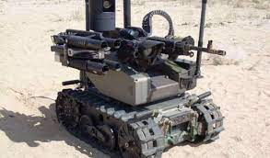

An example of the MAARS military robot used by the US Army

Summary
I- Robot Requirement Diagram
II- Mode of Movement
A) Possible Options
B) Advantages and Disadvantages of Each Mode of Movement and the Chosen Option
C) Chassis Selection
III- Sensors
A) Obstacle Detection
1) Ultrasonic Sensor
2) Lidar Sensor
B) Person Detection
C) Sensor Selection
IV- Chassis + Sensor Motors
A) Comparison of Stepper Motor and Servomotor for Lidar
B) Motor Selection for the Chassis
V- Cannon Rotation/Elevation Mechanism
A) Turret Rotation
B) Comparison of Hydraulic or Electric Motor for Turret Rotation (and thus the cannon)
C) Cannon Elevation
D) Proposed Equipment for DC Motor and Linear Actuator
VI- Firing Mechanism
A) Nerf Gun
B) Electromagnetic Cannon (Gauss Cannon)
VII- Battery
A) Types of Batteries and Comparison
B) Battery Selection
VIII- Conclusion
A) Summary Table of Purchases to be Made (if parts not owned and construction cost)
B) 3D Printing
C) Work Organization
D) Useful Links
Introduction:

In the context of an increasingly alarming political situation with growing tensions between global powers, particularly between China and the United States, and the ongoing conflict between Russia and Ukraine, not to mention the recent declaration of war in Israel, enhancing a country's military capabilities has become a necessity. Conducting military operations without risking the lives of soldiers has, therefore, become paramount.
At the forefront of technological innovation and the continual evolution of warfare machines, the Militech robot appears to be a plausible solution for the future of modern warfare. Equipped with four formidable tracks enabling all-terrain mobility, this robot is specifically designed to meet crucial strategic needs on the battlefield.
Its primary objective? To detect and neutralize targets using facial recognition with impressive precision, thanks to its multiple sensors and formidable magnetic cannon mounted on a turret to inflict substantial damage on the enemy.
This bibliography will delve into the technical aspects of the robot that we are about to design.

I- Requirement Diagram
This requirement diagram reflects our expectations for the robot in various categories, such as:
- Mobility
- Firing system
- Individual and obstacle detection system
- Autonomy
- Ability to communicate with individuals supervising the robot remotely

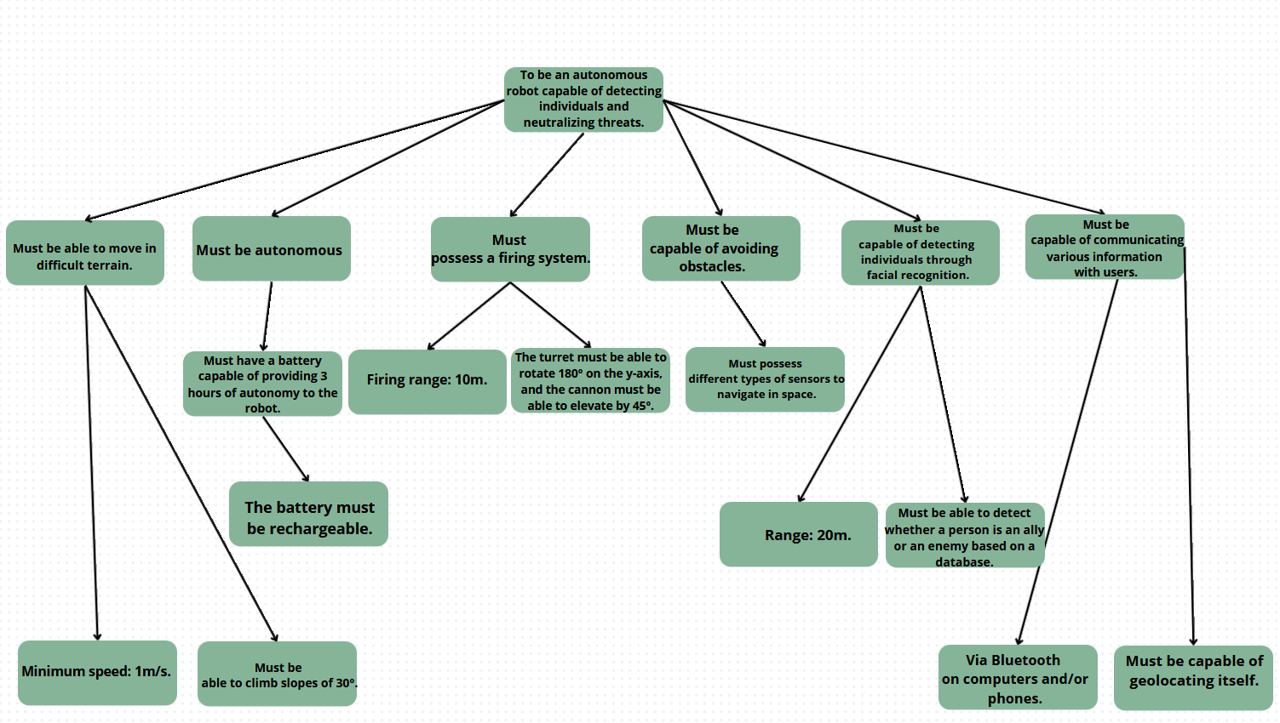
Diagram drawn using Canva Software

II-Mode of Movement:
There are several possible modes of movement for our robot, including the following:

A- Possible Options:
- Wheels
- Tracks
- On Legs

B - Advantages and Disadvantages of each mode of transport and the chosen option:

Type of movement | Advantages | Disadvantages
Tracks | - Excellent stability on rough and uneven terrain  - Low ground pressure suitable for fragile surfaces  - Good traction on loose terrain | - Generally slower than other options on smooth surfaces  - Requires fairly significant maintenance
Wheels | • Speed on smooth and regular surfaces  • Great maneuverability and agility  • Less maintenance | - -Less stability on rough terrain  - Higher ground pressure  - Less suitable for more challenging terrain

In conclusion, the choice of tracks seems more suitable for our robot, given that it needs to be all-terrain and high top speed is not necessarily required. Tracked platforms offer the ability to move on soft ground and maneuver through various types of obstacles. All-terrain tracked platforms move easily in snowy areas, marshy terrains, forests, and mountainous regions.

C-Choice of Chassis

The main difference between a robot with a 2-track (or tracklet) chassis and one with 4 tracks lies in the configuration of their mobility systems. Here are some important distinctions:

Characteristics | 2 Tracks | 4 Tracks (in pairs)
Maneuverability | • May have difficulties in making tight turns  • Can turn on the spot by varying the speed of the tracks on each side | -Better maneuverability, can pivot more easily on the spot
Load Capacity | Often capable of carrying heavier loads due to its stability | -Can also carry significant loads
Stability | Generally stable due to weight distribution on two tracks | -Can offer better weight distribution, improving stability in certain situations
Agility | -Less agile than 4-track robots. | -More agile, which can be an advantage in restricted environments.
Conclusion: We will opt for a 4-track chassis due to the stability constraints related to the components we are going to place, not to mention the advantage of the increased maneuverability of the 4 tracks.
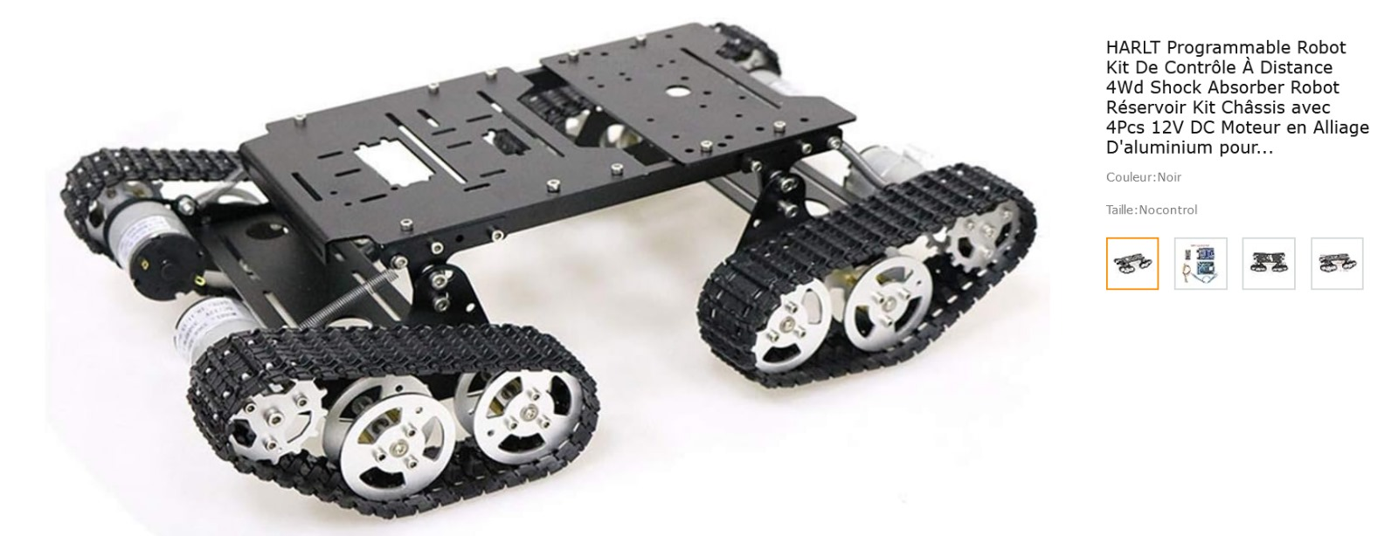
proposed Model found on www.amazon.fr
III- Sensors:
Our robot will need to perform two distinct tasks using sensors:
- Obstacle detection to navigate rough terrain without collisions
- People detection (facial detection (nose))

A- Obstacle detection:
We will use several types of sensors to make our robot more versatile and more precise in movement:
Characteristic | Ultrasonic Sensor | Laser Sensor (Lidar)
Operation | Ultrasonic sensors emit high-frequency sound waves (ultrasonic) and measure the time it takes for these waves to bounce off an obstacle and return to the sensor. | Obstacle detectors can utilize different technologies, including ultrasonic sensors, lidars, cameras, radars, etc., to detect the presence of obstacles.
Range | They have a limited range, typically from a few centimeters to a few meters, depending on the model. | The range depends on the type of sensor used. Obstacle detectors can be designed for short, medium, or long ranges.
Accuracy | Less accurate than lidars, ultrasonic sensors can be affected by multiple reflections and weather conditions. | Lidars offer high precision and high resolution, making them suitable for mapping and precise navigation.

Sensors choice:
a) Ultrasonic Sensor: HC-SR04 :

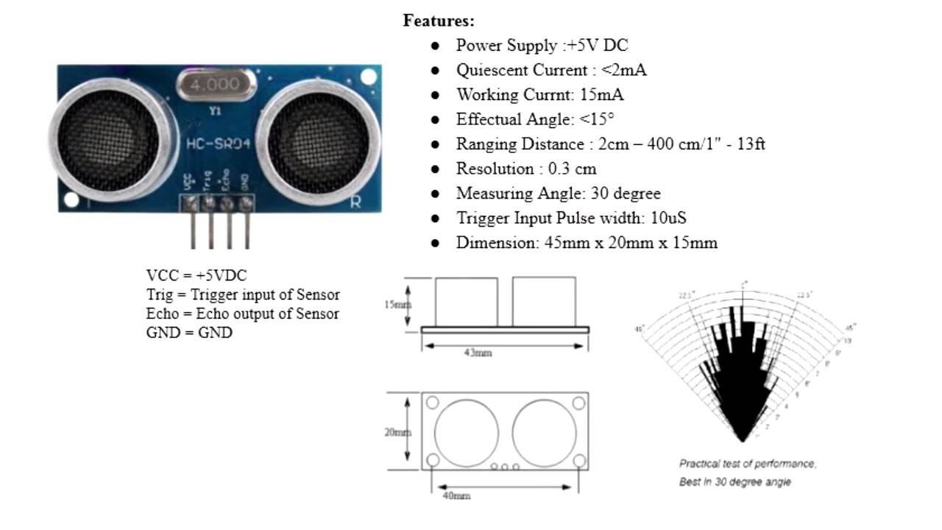

b) Laser Sensor (Lidar) : Model TF-Luna
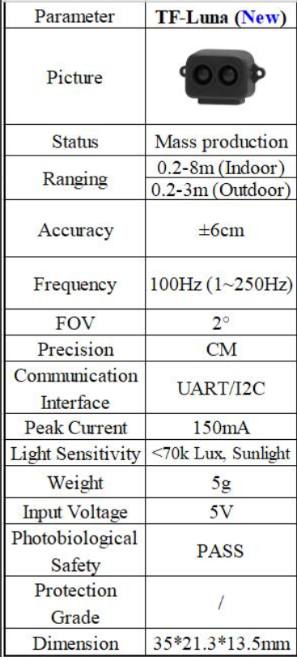
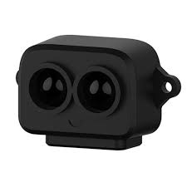
B-Persons detection:

Person detection is a crucial step in the operation of our robot, and it will be carried out using OpenCV software, widely used in the fields of computer vision, machine learning, and robotics to perform a variety of tasks related to image and video analysis, coded in Python and C++. We will need a camera to perform person detection.

Webcam choice :

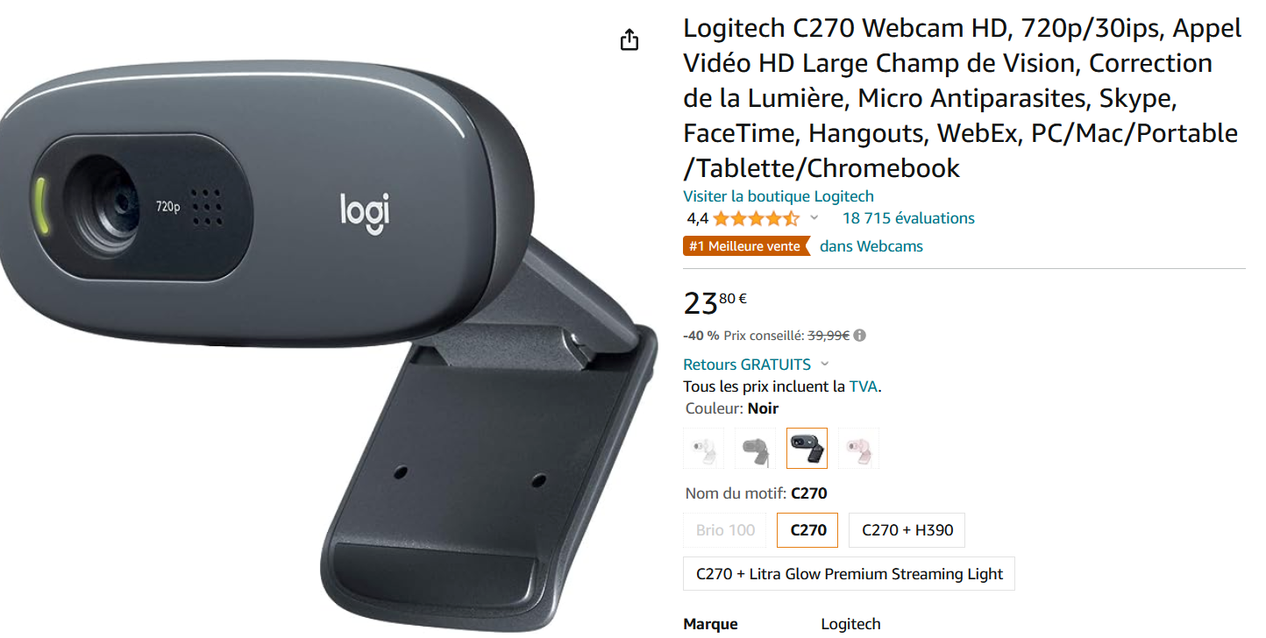
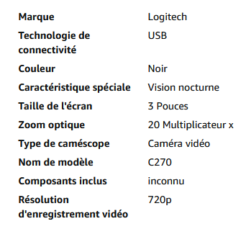
C- Sensors placement :
At least one ultrasonic sensor will be placed on each front and rear face of the robot, and one ultrasonic sensor per side view of the caterpillar, meaning two per side. The following diagram represents our robot from a top view:
- The crosses correspond to the location of the sensors.
- The arrows correspond to the direction of action of the sensor.
Additionally, "obstacle detectors" can be added to each caterpillar.

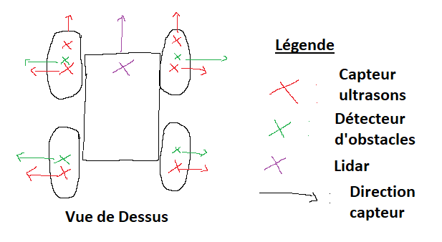
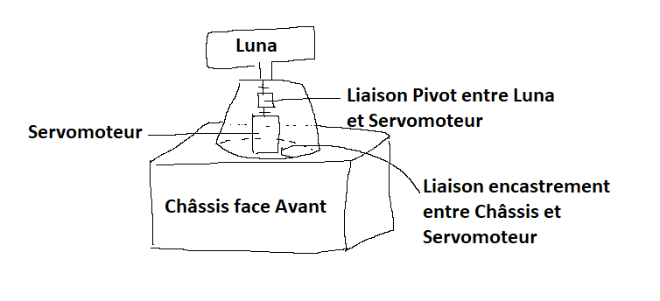
The Luna laser sensor should be positioned in such a way that it can perform a 180-degree rotation on the front face. For this purpose, we will need to mount it on a servo motor that will continuously perform a half rotation. To prevent any tearing of the servo motor that allows the Luna sensor to rotate, we will proceed with the 3D printing of the following diagram:

IV- Motors for the chassis + Lidar
Motors are an integral part of our project, as they convert energy created from electricity into noticeable mechanical motion. They will be present in the following locations:
- In each of the caterpillars: 1 12V 350 RPM DC motor per caterpillar (delivered with the chassis).
- At the base of our Luna Lidar for a 180-degree rotation.
- Under the turret of our firearm.
Thus, the choice of motor type is crucial for the rotation of our Lidar.
A) Comparison between a stepper Motor and a servo Motor
Characteristic | Stepper Motor | Servo Motor
Use | Stepper motors are very easy to set up. | Easy to use on an Arduino board. Capable of rotating at high speed while maintaining the nominal torque.
Rotation speed | If a higher speed is required, then the sizing of the motor will need to be increased. | Capable of rotating at high speed while maintaining the nominal torque.
Accuracy | When the torque decreases, the motor may "skip" a step, meaning the motor will not follow the motor controller's command. At low speeds, stepper motors have coarse precision (unless they are constructed with micro-stepping, meaning with a large number of angular divisions). | - These motors are equipped with encoders, making them precise and reliable. They require complex encoders. If the encoder is not configured correctly, it may require more maintenance.
Entretien | -This type of motor is durable and requires low maintenance.  - These motors are noisy and can suffer from resonance issues. | • Servo motors also have a few disadvantages: these motors can be very expensive. This adds an element of complexity to the system and therefore an additional cost.  • Servo motors may also require the addition of a speed reducer to use low rotation speeds or to increase the available torque.
Couple | - Servo motors offer a very good holding torque, thus they do not need a brake to maintain the system in position. The torque remains strong even at low speeds.  -For a stepper motor, the torque decreases significantly as the speed increases. | - They can withstand up to nearly twice their nominal torque for a short period

Indeed, for the intended use (lightweight Lidar and 180° rotation), a Servo motor appears to be the suitable choice. Its ability to rotate swiftly and maintain torque, along with the precise and reliable performance due to the built-in encoders, makes it well-suited for this purpose.
B) Choice of motors for the chassis: Number of motors used and choice of motor type for the chassis + Lidar:
- For the rotation of the caterpillars: We will use 4 12V 350 RPM DC Motors provided with the chassis.
- For the rotation of the Lidar: We will use a servo motor (which is available in the project room).
- V) Cannon Rotation/Elevation Mechanism
The rotation and elevation mechanism of the cannon will be crucial for our Robot. Technically, it seems improbable to hit a target at a distance (10 meters) without being able to elevate our cannon due to the parabolic trajectory that the fired ammunition will take.

Similarly, the rotation of the cannon is a significant advantage in terms of speed gain for our robot. This rotation would prevent the robot from having to turn its chassis to align with its target. Furthermore, in the case of a moving target, tracking it solely through the rotation of the chassis would prove very challenging due to terrain constraints on one hand (terrain inclination) and the distance of the target (max 10 meters), which would require a high rotation speed at close range.

Several technical solutions are possible, but the main one remains the turret:

A) Turret Rotation:
The turret is the system that will allow our robot to aim its cannon at any target. It is primarily used today in most military vehicles (tanks/AFVs).
Rotation of the weaponry: The turret allows the main armament (usually a cannon) to pivot in all directions, enabling the tank to aim and fire at targets 360 degrees around it without having to move the entire vehicle. This gives the tank great agility on the battlefield. The turret's ability to rotate quickly allows the tank to react swiftly to emerging threats, whether they are moving enemy targets or fire coming from different directions.
The choice of motor for a tank turret depends on several factors, including the size of the turret, the weight of the armament it needs to move, the desired mobility, and the power requirements. The most commonly used motors in the military currently are electric or hydraulic.

B) Comparison between a hydraulic and an electric Motor:

Motor type | Hydraulic | Electric
Pros | -Precise control: Hydraulic systems can offer precise control of speed and torque using regulating valves. | -• Energy efficiency: Electric motors are generally more efficient than hydraulic motors, meaning they waste less energy in the form of heat.  • Less maintenance: Electric motors tend to require less maintenance than hydraulic systems because they have fewer moving parts prone to wear and tear.
Cons | -Energy efficiency: Hydraulic systems are often less efficient than electric systems in terms of efficiency.  -Noisy: Hydraulic systems can be noisy due to the circulation of oil under high pressure.  -Maintenance: Hydraulic systems often require more maintenance than electric systems due to component wear and potential oil leaks. | -Limited power: Electric motors have limited power compared to hydraulic motors, which can make them less suitable for heavy loads.  -Difficulty controlling torque: Electric motors sometimes struggle to provide high torque at low speeds, which can be a disadvantage in certain applications.
for ease of use, we will choose an electric DC motor for the rotation of the turret, given that the mass of the turret to be rotated remains manageable.
Regarding the elevation of the cannon, a major issue arises in the technical design of the turret. On the one hand, the space required for the firing system (electromagnetic cannon consisting of various capacitors and coils). On the other hand, the mass of the firing system (estimated to be between 2 and 3 kg), which makes the use of a motor potentially tricky with the available equipment (high risk of tearing and therefore risk of breakage due to the significant mass to be lifted), necessitating the choice of a different technical solution.
C) Cannon Elevation:
After various research, an interesting technical solution that could be used is as follows: the use of a linear actuator: Linear actuators are mechanical devices designed to produce linear motion (in a straight line) rather than rotary motion. Linear actuators are capable of providing precise and controllable linear motion. This makes them ideal for applications where precision is essential. There are several types of linear actuators (hydraulic/pneumatic/mechanical/electric). For ease of use, we will once again choose an electric linear actuator.
We will model our turret as follows: The cannon will be attached to a pivot joint in height, which will be fixed to a rotating platform. The rotating platform will be mounted on a ball bearing, useful due to their specific design that reduces friction between moving surfaces, and their ability to support significant radial loads (perpendicular to the axis of rotation) and axial loads (parallel to the axis of rotation). The rotating platform will be powered by a DC motor for the rotation of the cannon. The linear actuator, mounted on the rotating platform (and rotating with the cannon), will allow the elevation of the cannon. (See diagram)
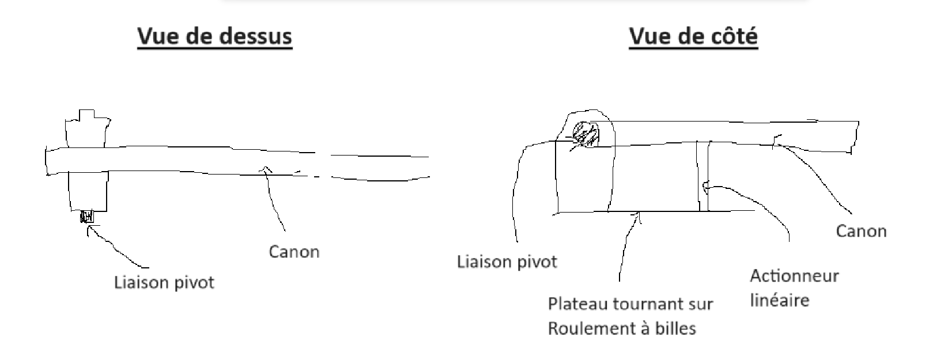
D) Equipment Proposed for the DC Motor and Linear Actuator:
- Choice of motor for the rotation of the turret:
Through simulation on the RoboShop tool, for a mass of 3kg to rotate, and assuming that the rotating platform will have a diameter between 10 and 20 cm, we will need the following characteristics for our motor, that is, a motor capable of providing a maximum torque of 1.65 N.m.

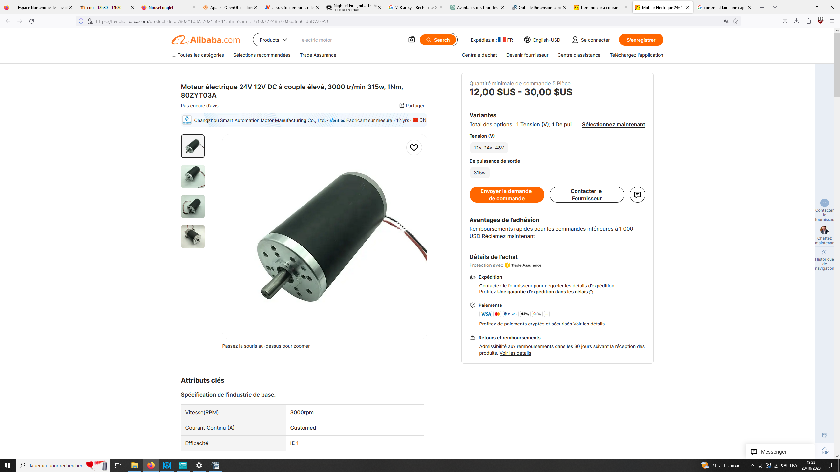
However, since the motor will be placed on a ball bearing and should not act against excessive friction forces, we can choose a motor with slightly less torque (1Nm).

- Choice of linear actuator:
We propose the following linear actuator, which is a rod actuator and seems to perfectly match our needs. In addition to being electric, it has the advantage of being compact and having a 10cm stroke (sufficient for our robot).
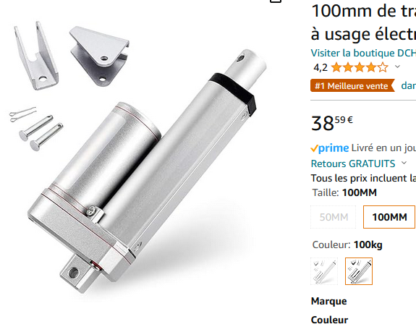
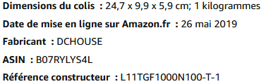
VI- Firing Mechanism
The firing mechanism is the system that will allow us to neutralize our target from a distance. Several technical solutions enable us to achieve this option. Due to the constraints related to the potential danger of use, we will only consider a system capable of hitting its target from a distance with moderate firepower. Two usable options are highlighted:

A) Nerf-Gun ( First semester, prototype if we find the appropriate time)

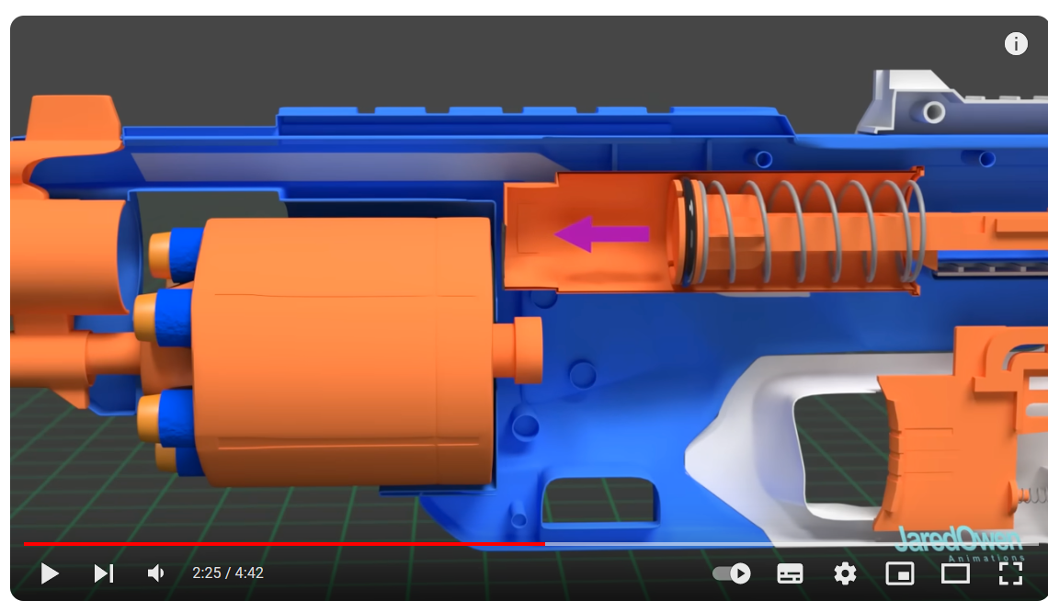
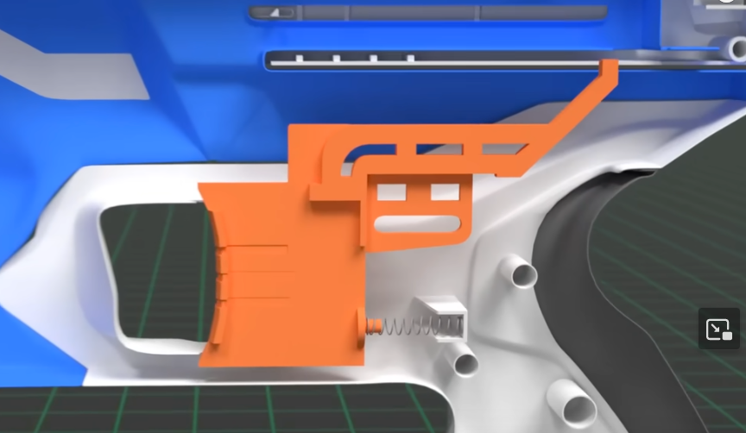
Nerf guns fire foam, rubber, or gel projectiles, such as darts or balls. Most Nerf guns operate by using compressed air to propel the darts. By pulling or pressing a handle, the air inside the gun is compressed. The compressed air then propels a piston that ejects the dart at a reasonable speed.
For details watch the video :
https://youtu.be/N8JpePwvuHw?feature=shared&t=67

Advantages of the solution:
- Relatively safe
- Easy to implement (requires minimal onboard electronics)
Disadvantages:
- Very short shooting range
- Risk of deviation of the dart during firing (friction and wind will have a strong impact on the dart's trajectory since it's made of foam), leading to inaccuracy
- Limited onboard ammunition (a suitable ammunition storage and reloading system will be needed)

B) Gauss Cannon: (Second semester)

The Gauss cannon is a type of cannon that utilizes the magnetic attraction/repulsion effect. It proves to be highly innovative and is starting to be developed on a large scale in armies due to its effectiveness. We will use the proposed firing system below, based on an assembly of coils, 450V, and 680 Microfarad capacitors, and various components such as resistors/thyristors/phototransistors/transistors to propel metal balls that will reach our targets. (See list of materials below) Circuit diagram allowing the modeling of the Gauss cannon.
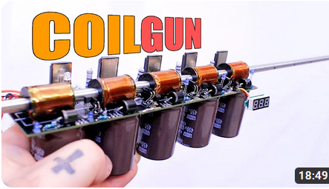
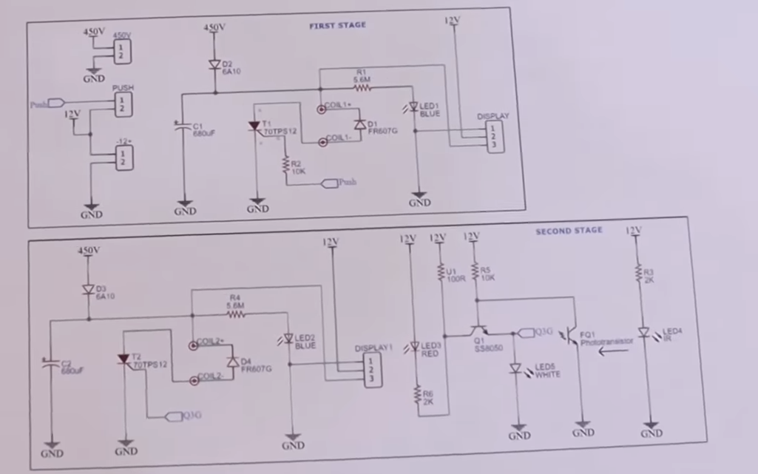
Video used for assembly reference: https://www.youtube.com/watch?v=id90kjYh-Qw
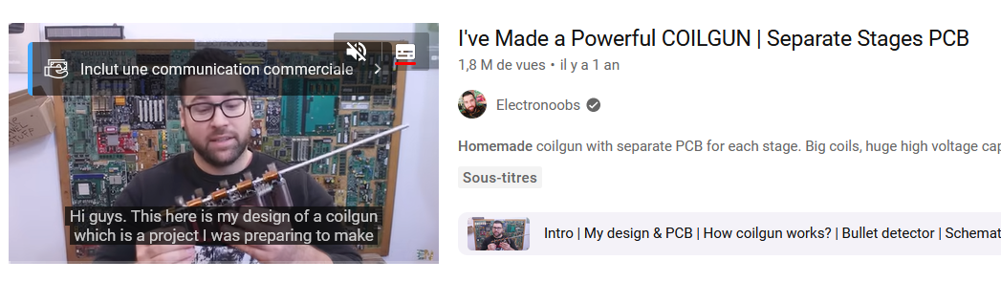
Pros of the solution:
- Significant precision
- Adjustable power (The construction of the cannon is based on a series combination of the same circuit repeated multiple times and connected in series (consisting of coils/capacitors/resistors/thyristors/phototransistors/transistors...) mounted on PCB, so adding or removing PCBs is sufficient to modulate the power of the cannon.
Disadvantages:
- Significant mass (estimated between 2 and 3 kg)
- Takes up space
- More challenging to implement (requires soldering/extensive electronics)
- Energy-intensive
We will use the electromagnetic cannon on our robot (also to learn various concepts in electronics and experiment with soldering components on PCB for the first time).

VII- Battery:
  - Types of Batteries and Comparison
There are several types of batteries, among the most common are:
- Li-Ion Batteries: Li-ion batteries are popular due to their high energy density, lightweight nature, and rechargeability. They are suitable for various types of robots, including domestic robots, drones, robotic toys, and more.
- Lithium Polymer Rechargeable Batteries (LiPo): Li-Po batteries are similar to Li-ion batteries in terms of performance, but they are generally thinner and more flexible, making them suitable for robots with specific shapes. However, they remain dangerous due to the significant risk of fire or explosion.
- Lead-Acid Batteries: Lead-acid batteries are larger and heavier than Li-ion batteries, but they are less expensive and can be suitable for larger robots, such as service robots.
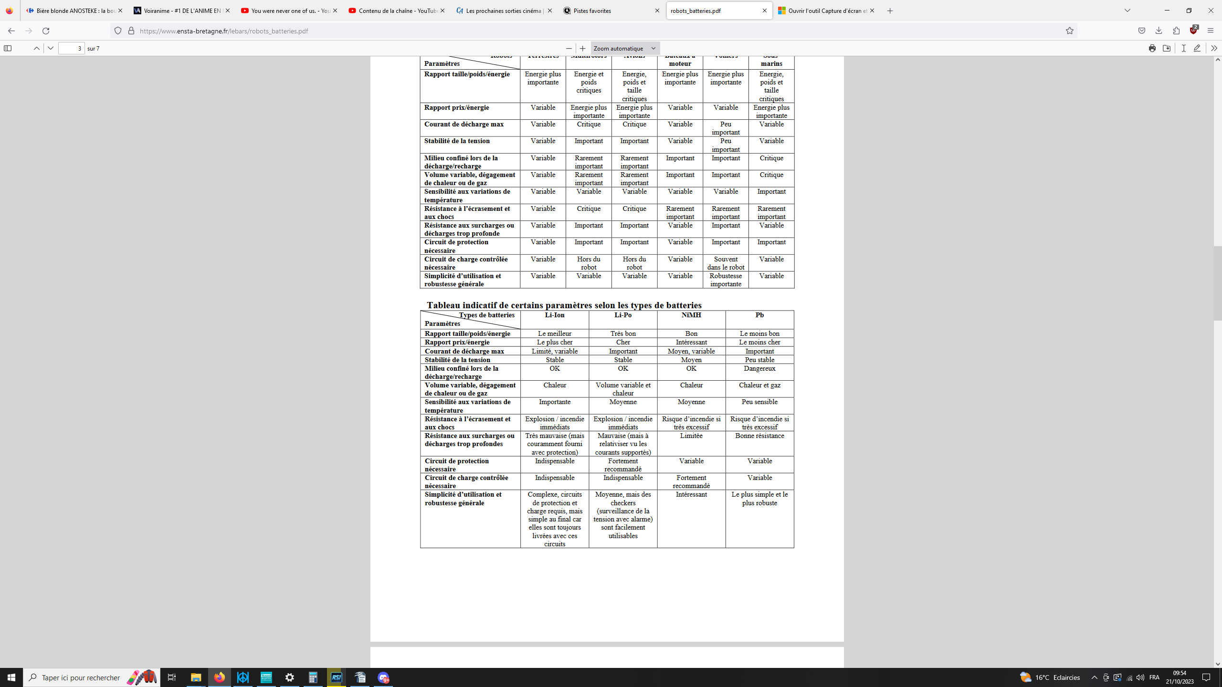
B)Battery Choice:

We will use a Li-Po battery to power our robot, due to its very favorable weight-to-size ratio. The 5200mAh capacity of the following battery will ensure good autonomy for our robot without taking up too much space.

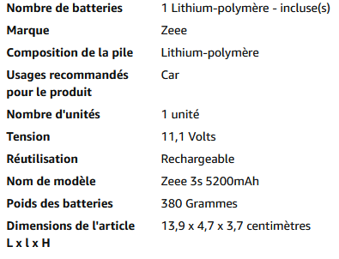
We will take precautions to ensure that we strictly adhere to the safety instructions provided by the manufacturer. Converters will be used, especially to power our various boards: (12V-5V for our multiple Arduino boards used to power the sensors or our potential future Jetson Nano board).

VIII-Conclusion:
A) Summary Table of Purchases to be Made (if parts are not owned) and Construction Costs:
Piece | Price | Links
1xChassis+4 Motors 12V 350RPM NO CONTROL | 169,00 € | https://www.amazon.fr/HARLT-Programmable-R%C3%A9servoir-Daluminium-Bricolage/dp/B082NMNFMJ?th=1
1xLidar TF-Luna | 44,99 € | https://www.amazon.fr/Benewake-TF-Luna-D%C3%A9tecteur-D%C3%A9tection-V%C3%A9hicules/dp/B087QWT52L/ref=sr_1_2?keywords=tf+luna+lidar&qid=1697825840&sr=8-2
1x Rod Actuator. | 49,99 € | https://www.amazon.fr/DCHOUSE-Actionneurs-mouvement-%C3%A9lectronique-dautomatisation/dp/B07RYLYS4L/ref=sr_1_4?__mk_fr_FR=%C3%85M%C3%85%C5%BD%C3%95%C3%91&crid=1FQEJS4GUHUF1&keywords=actionneur%2Blin%C3%A9aire&qid=1697877867&s=industrial&sprefix=actionneur%2Blin%C3%A9aire%2Cindustrial%2C79&sr=1-4&th=1
6 x ultrasonic Captors HC-SR04 | 9,59 € | https://www.amazon.fr/pi%C3%A8ces-HC-SR04-Ultrasonique-Capteur-Distance/dp/B0CFXX89D7/ref=sr_1_10?__mk_fr_FR=%C3%85M%C3%85%C5%BD
1x Servo motor Lidar | 4 pieces for11,99 € | https://www.amazon.fr/HUAZIZ-servomoteur-h%C3%A9licopt%C3%A8re-Voiture-contr%C3%B4le/dp/B09Z21J1JH/ref=sr_1_5?__mk_fr_FR=%C3%85M%C3%85%C5%BD%C3%95%C3%91&crid=1OGGXOM9KGC0O&keywords=servomoteur+arduino&qid=1697826044&sprefix=servomoteur+arduino%2Caps%2C79&sr=8-5
1x Motor CC Turret | 12,00 € | https://french.alibaba.com/product-detail/80ZYT03A-702150411.html?spm=a2700.7724857.0.0.b3da6adbDWceA0
1x Gauss Cannon | Total: 120€ | https://electronoobs.com/eng_circuitos_tut74_parts1.php
1x Motor CC Turret | 12,00 € | https://french.alibaba.com/product-detail/80ZYT03A-702150411.html?spm=a2700.7724857.0.0.b3da6adbDWceA0
1x Ball Bearing 50x80x16mm. | 22,99 € | https://www.amazon.fr/XiKe-roulements-6001ZZ-pr%C3%A9-lubrifi%C3%A9s-rentables/dp/B0B2K4K5F8/ref=sr_1_5?__mk_fr_FR=%C3%85M%C3%85%C5%BD%C3%95%C3%91&crid=2922Z8VFTHSHE&keywords=roulement%2B%C3%A0%2Bbille%2B10cm&qid=1697827153&sprefix=roulement%2B%C3%A0%2Bbille%2B10%2Bcm%2Caps%2C73&sr=8-5&th=1
Logitech Webcam C270 | 24,10 € | https://www.amazon.fr/Logitech-Webcam-Vid%C3%A9o-Microphone-Int%C3%A9gr%C3%A9/dp/B01BGBJ8Y0/ref=sr_1_1?__mk_fr_FR=%C3%85M%C3%85%C5%BD%C3%95%C3%91&crid=21K3UJT4C7MSA&keywords=camera+c270&qid=1697827341&sprefix=camera+c270%2Caps%2C98&sr=8-1
Battery Li-po 3S | 38,00 € | https://www.amazon.fr/Zeee-Batterie-connecteur-Quadcopters-H%C3%A9licopt%C3%A8re/dp/B0813GPBTF/ref=sr_1_9?keywords=lipo+3s&qid=1697876603&sr=8-9
TOTAL | 470,00 €

B) 3D Printing:
Due to its versatility, we will carry out each of our prints for our project using PETG.
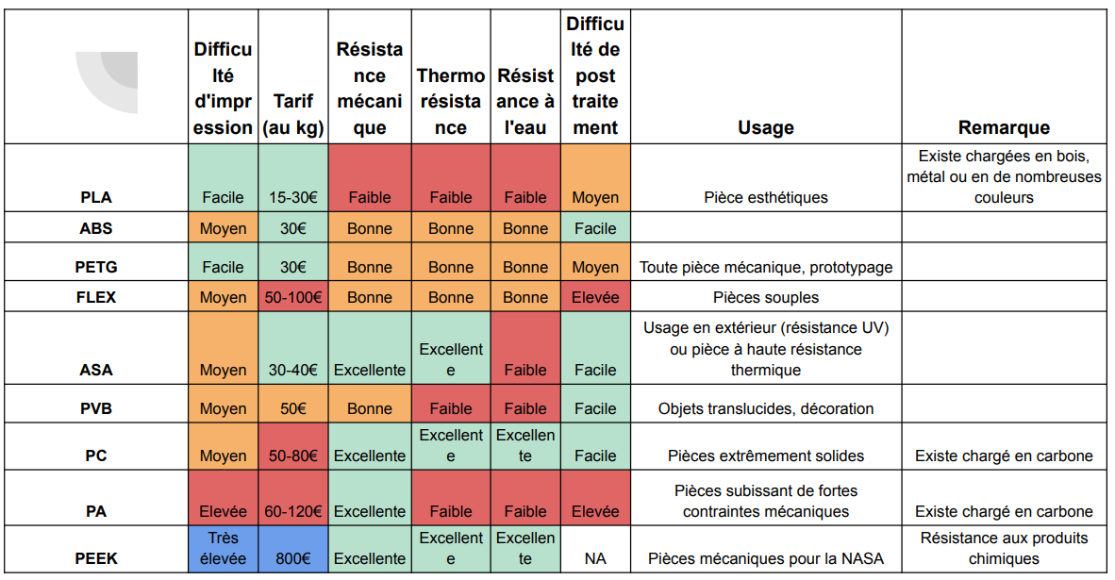

C) Work Organization :
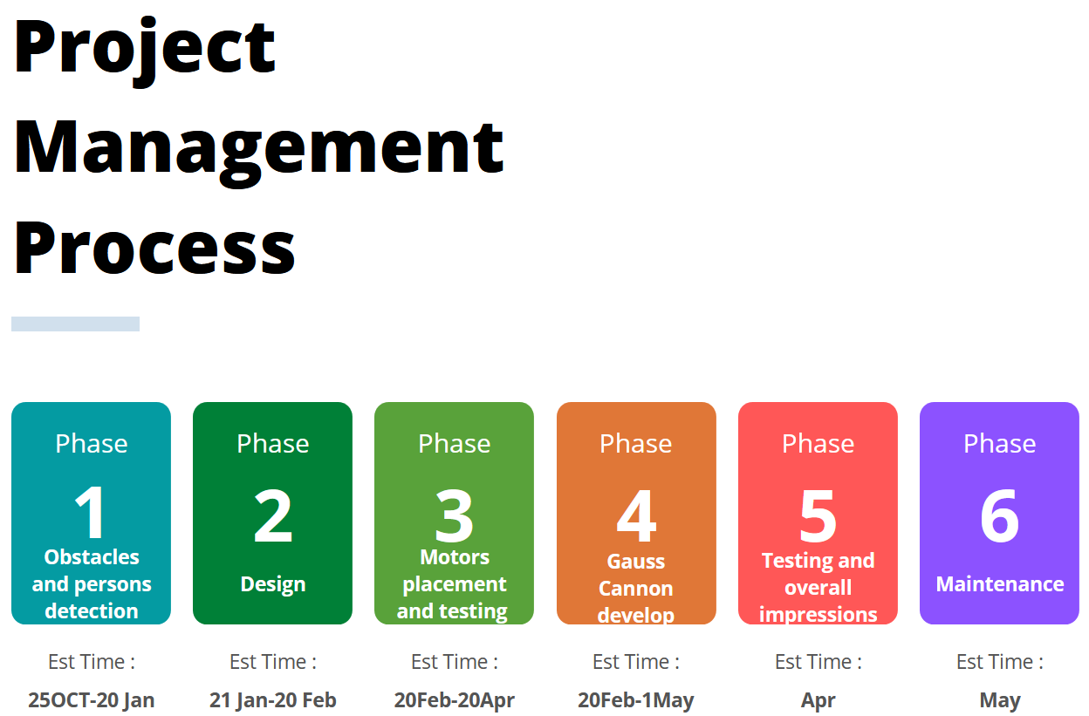

The load of work will be divided into two persons

A-Youssef Miri
a-First Phase:
-OpenCv Software for facial recognition and person detection.
-coding using Python and C++ for Arduino configurations.
b-Second and Third phases:
-3D printing: creating prototypes of different components using Fusion 360.
-Motors configuration for proper functioning along with Arduino/Jetson coding
B-Nicolas Consalvi:
a-First Phase:
-ultrasonic and lidar sensor configurations for obstacle detection.
-Arduino coding for sensors using C/C++
b-Secord and third phases:
-Creating the base of our turret using laser cutting along with 3D Printing (if needed)
-Proper placement of motors along with their batteries and first impressions.
Fourth phase:
This phase will be achieved by the two students during the second semester since it is a complex part of our project that demands a lot of precision and electrical configurations.
Last two stages:
-During these two stages, our main goal is to guarantee the proper functioning of our robot using different testing methods including simulations along with proper deployment involving testing the robot's functionality and ensuring that it operates as intended in its designated environment.
-Like any other piece of technology, robots require regular maintenance to ensure their optimal performance. Monitoring the performance of the robot can help identify any potential issues early on, allowing for timely repairs and adjustments.

References :

[1]:Stepper Motor pas à pas or Servo Motor https://www.motionsquare.fr/servomoteur-ou-moteur-pas-a
-pas/
[2]: ultrasonic or laser Sensor:https://www.electronique-mixte.fr/wp-content/uploads/2018/10/Capteur-ultrasonique.pdf
[3]: Battery Choice and precautions: https://www.ensta-bretagne.fr/lebars/robots_batteries.pdf
[4]:Canon Gauss : https://www.youtube.com/watch?v=id90kjYh-Qw
[5]: 1x Rod Actuator.: https://www.firgelliauto.com/en-fr/pages/what-is-a-linear-actuator
[6]: Electric vs hydraulic motors:https://control.com/technical-articles/fluid-or-electric-power-understanding-hydraulic-and-pneumatic-motors/
[7] : Technology Lidar: https://www.generationrobots.com/blog/fr/qu-est-ce-que-la-technologie-lidar/
[8] : Person detection with OpenCV Software: https://datacorner.fr/reco-faciale-opencv/
[9] : functioning of the Nerf-Gun: https://youtu.be/N8JpePwvuHw?feature=shared&t=67

